Assessment Schedule – 2015 Physics: Demonstrate understanding of electrical systems (91526)

Evidence
Q | Evidence | Achievement | Achievement with Merit | Achievement with Excellence
ONE  (a) | 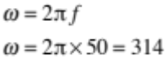 | - 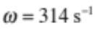
(b) | 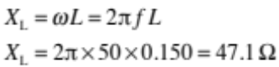 | - Correct workings shown.  (SHOW THAT Q)
(c) | 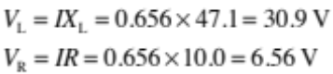  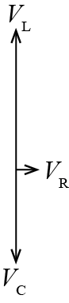 | - Calculates values for V_{L} and V_{R}.  OR  - Draws phasors to represent V_{C} and V_{L} and V_{R} with correct phase shift. | - Calculates values for V_{L} and V_{R}.  AND  Draws phasors to represent V_{C} and V_{L} and V_{R} with correct phase shift. | - Calculates values for V_{L} and V_{R}.  AND  Draws phasors to represent V_{C} and V_{L} and V_{R} with correct phase shift and correct sizes.
(d) | In an AC circuit, V_{L} and V_{C} are 180° out of phase.  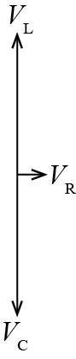  At resonance, X_{L} = X_{C} so X_{L} – X_{C} = 0  Z = R so 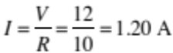 | - V_{L} and V_{C} are 180° out of phase.  - X_{L} = X_{C}  - V_{L} = V_{C}  - I = 1.20 A (no explanation) | - The impedance of the inductor and the capacitor cancel out, due to the opposite phase of the capacitor and the inductor therefore Z = R.  OR  - X_{L} = X_{C} , Z = R  OR  - Excellence answer but no explanation that Z is minimum | Explains why the impedance of the circuit is a minimum ie it equals the resistance of the circuit at resonance, describing the equal reactance but opposite phase of the inductance and the capacitance so

Not Achieved |  |  | Achievement |  | Achievement with Merit |  | Achievement with Excellence
NØ | N1 | N2 | A3 | A4 | M5 | M6 | E7 | E8
No response; no relevant evidence. | A | 2 A | 3 A  1 M | 4 A  1 M & 1 A | 1 M & 2 A  1 E | 2 M  1 E & 3 A | E & M | 2 E

Q | Evidence | Achievement | Achievement with Merit | Achievement with Excellence
TWO  (a) | Calculate voltage across cell  9.00 – 6.40 = 2.60 V  Uses this to show that  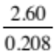 = 12.5 Ω  OR r = R_{T} – R_{C} | - V_{r} = 2.60 V  - r = R_{T} – R_{C} | - r = 12.5 Ω  (Must clearly indicate how 2.6 is derived)  (SHOW THAT Q)
(b) | 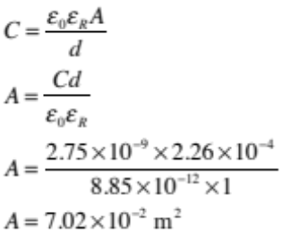 | - A = 7.02 × 10^{–2} m²
(c) | 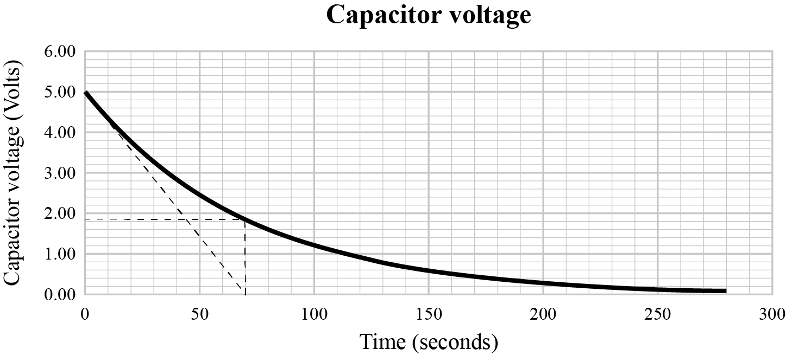  63% change interpolated on graph as 65 – 75 by either method.  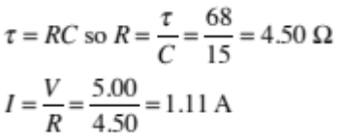 | - Correct method used to estimate time constant.  - Shows some understanding of a decrease in V leading to extrapolating Time constant.  - Correct method used leading to incorrect I (used 33/37 or 63/67%) | - Correct method used to estimate time constant.  AND  Time constant used to calculate R.  (SHOW THAT Q) | - Correct method used to estimate time constant.  AND  Time constant used to calculate R.  AND  Initial current calculated from τ and R.
(d) | E = ½CV ² = ½ × 400 × 5.00² = 5000 J  This is about 1% of the 6 × 10⁵ J of energy required.  τ = RC = 4.5 × 400 = 1800 s  The time to fully discharge, 5 time constants is 9000 s.  The capacitor will take a long time (2.5 hours) to discharge and does not rapidly discharge. | - E = ½CV ² = ½ × 400 × 5²  = 5000 J  - τ = RC = 4.5 × 400 = 1800 s  - Discharge will occur in 4 – 5 time constants. | No it won’t charge because:  - E = ½CV ² = ½ × 400 × 5² = 5000 J. This is less than the energy required.  OR  - τ = RC = 4.5 × 400 = 1800 s  The capacitor will take about 9000 s to discharge (5 time constants is 9000 s). This is too long. | No it won’t charge because:  - E = 6 × 10⁵, Q = 2.6 × 10⁵,  so C = 4800 F, this is much larger than 400 F  AND  τ = RC = 4.5 × 400 = 1800 s  The capacitor will take about 9000 s to discharge (5 time constants is 9000 s or reference to fact that its 63% discharged). This is too long.  OR  - E = ½CV ² = ½ × 400 × 5²  = 5000 J. This is less than the energy required.  AND  τ = RC = 4.5 × 400 = 1800 s  The capacitor will take about 9000 s to discharge (5 time constants is 9000 s or reference to fact that its 63% discharged). This is too long.

Not Achieved |  |  | Achievement |  | Achievement with Merit |  | Achievement with Excellence
NØ | N1 | N2 | A3 | A4 | M5 | M6 | E7 | E8
No response; no relevant evidence. | A | 2 A  1 M | 3 A  1 M & 1 A | 4 A  1 M & 2 A  2 M | 2 M & 1A  1 E | 3 M  1 E & 3 A | E & M | 2 E

Q | Evidence | Achievement | Achievement with Merit | Achievement with Excellence
THREE  (a) | Inductors store energy as magnetic fields. | - Magnetic fields.
(b) | 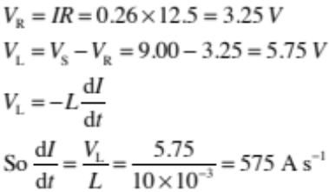 | - V_{R} calculated.  AND  V_{L} calculated. | - V_{R} calculated.  V_{L} calculated.  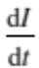 calculated.
(c) | When the switch is closed, the change in current, , is very great so the reactive inductor opposes the change in current (producing a back emf), so most of the current goes through the bulb (as these two components are in parallel). As becomes smaller, the opposition of the inductor (its effective resistance) becomes smaller so more current flows through the inductor and less through the bulb. | - Explains why initially little current flows through the inductor.  - Inductor produces a back emf / induced voltage  - Less current in bulb, less Power | - Explains why initially little current flows through the inductor  AND  Explains why finally most of the current flows through the inductor and not the resistor. | - Explains why there is a change in I  AND  Less current in bulb, less Power
(d) | A changing (alternating) current inducing a changing (fluctuating) magnetic field around the coil of wire.  The size of the field is determined by the frequency of the alternating current.  Changing / fluctuating magnetic fields cause currents to flow in the bicycle wheels.  By Lenz’s law, a current creates a magnetic field that opposes the magnetic field that created it – the higher the frequency, the greater the eddy currents. The induced magnetic field always opposes or reduces the field that created it. | - Alternating currents have fluctuating magnetic fields/flux.  - Changing flux will induce a voltage  - Opposite direction due to Lenz’s Law.  - High frequency results in large induced voltage / (rate of) change in current. | - Changing flux results in an induced voltage / current / field (Faraday’s Law).  AND  It will be large because rate of flux change is large due to high frequency.  OR  - Changing flux results in an induced voltage / current / field (Faraday’s Law).  AND  It is in opposite direction to oppose change/ the current (Lenz’s Law). | Changing flux results in an induced voltage / current / field (Faraday’s Law).  AND  It will be large because rate of flux change is large due to high frequency.  AND  It is in opposite direction to oppose change / the current (Lenz’s Law).

Not Achieved |  |  | Achievement |  | Achievement with Merit |  | Achievement with Excellence
NØ | N1 | N2 | A3 | A4 | M5 | M6 | E7 | E8
No response; no relevant evidence. | A | 2 A  1 M | 3 A  1 M & 1 A | 4 A  1 M & 2 A  2M | 2 M & 1 A  1 E | 3 M  1 E & 3 A | E & M | 2 E

Cut Scores
Not Achieved | Achievement | Achievement with Merit | Achievement with Excellence
0 – 6 | 7 – 14 | 15 – 18 | 19 – 24

